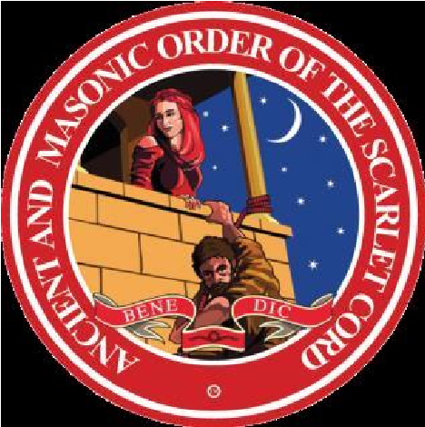
The Order of The Secret Monitor
For the Sovereign State of New South Wales and The Australian Capital Territory
(Formed 30th October 1958)
Scarlet Cord Conclave Number 30
APPLICATION FORM for 2nd Grade
The Scarlet Cord Conclave No. 30 will meet at
Artarmon Masonic Centre on Sat’ 11th May 2024 Tyling at 4pm
Date: ........ /…...….... /2024
Family Name: ............................................ Given Names: ………………………………….
Conclave: ............................................................................................. No: ....................
Residential Address: .........................................................................................................
Phone No: ........................................................Mobile: ………….………………….….…...
Email: .................................................................................................................................

Purchase the 2nd Grade Jewel; OR | $ 35.00
Exchange the 1st Grade Jewel for the 2nd Grade Jewel, | No Charge
As a Steward of the OSM Fund of Benevolence, I wish to donate a further sum of $50:00 [minimum] to be promoted to the 2nd Grade. | $50.00
Total |  | $
For Electronic Funds Transfer (EFT) to the Carlingford Commonwealth Bank of Australia the following information is needed: Account Name: Scarlet Cord No. 30,
BSB: 062 300, Account No.; 10332264, and put “SC-2nd ‘initial, your family name and Registration’ in the description section of the EFT document. *** IMPORTANT*** Then email the Application Form with identification of payment to the Secretary.
Alternatively, I enclose my cheque payable to "Scarlet Cord Conclave No.30.” for: $.................... with the completed Application Form.
The completed Application Form and evidence of payment must be received by the Secretary on or before 4th May 2024
Secretary:
M. McDonald Email: mcdonald.markandrew@gmail.com
13 Ixion Street
Winston Hills NSW 2153
M: 0417 678 435
Candidates for the Second Grade MUST be a current First Grade member of the Scarlet Cord. If in doubt refer to the Secretary/Recorder.
Please Note: Your own VSL is required during the ceremony.

